Teacher Notes for
“Gene Editing with CRISPR-Cas – A Potential Cure for Severe Sickle Cell Anemia”

This analysis and discussion activity introduces Victoria Gray whose severe sickle cell anemia was effectively treated by gene editing with CRISPR-Cas. To begin, students review the molecular biology of sickle cell anemia, transcription and translation. Next, they learn how bacteria use CRISPR-Cas to defend against viral infections. Then, students examine some of the research findings that scientists used to identify the target for gene editing. Finally, students analyze the CRISPR-Cas gene editing treatment for sickle cell anemia. These Teacher Notes present an optional additional video and question to stimulate students to consider the ethical controversies related to potential uses of CRISPR-Cas.

Before your students begin this activity, they should be familiar with DNA, RNA, proteins, transcription, and translation. For this purpose, I suggest our transcription and translation activity, which includes a section on sickle cell anemia. The hands-on, minds-on version of this activity is available at https://serendipstudio.org/sci_edu/waldron/#trans, and the analysis and discussion version is available at https://serendipstudio.org/exchange/bioactivities/trans.

Learning Goals
In accord with the Next Generation Science Standards:
- Students prepare for the Performance Expectation HS-LS3-1. "Ask questions to clarify relationships about the role of DNA and chromosomes in coding the instructions for characteristic traits passed from parents to offspring."
- Students learn the following Disciplinary Core Ideas:
- LS1.A – Structure and Function. "Genes are regions in the DNA that contain the instructions that code for the formation of proteins."
- LS3.A – Inheritance of Traits. “Each… gene on the chromosome is a particular segment of that DNA. The instructions for forming species’ characteristics are carried in DNA. All cells in an organism have the same genetic content but the genes used (expressed) by the cell may be regulated in different ways. Not all DNA codes for a protein; some segments of DNA are involved in regulatory or structural functions, and some have no as-yet known function.”
- Students engage in this recommended Scientific Practice:
- “Constructing Explanations. Apply scientific ideas, principles, and/or evidence to provide an explanation of phenomena…”
- This activity provides the opportunity to discuss two Crosscutting Concepts:
- "Cause and Effect: Mechanism and Prediction. Cause and effect relationships can be suggested and predicted for complex natural and human designed systems by examining what is known about smaller scale mechanisms within the system."
- "Structure and Function. Investigating or designing new systems or structures requires a detailed examination of the properties of different materials, the structures of different components, and connections of components to reveal its function and/or solve a
problem."
- This activity helps students to understand an aspect of the Nature of Science.
- “Scientific investigations use a variety of methods, tools, and techniques to revise and produce new knowledge.”

Instructional Suggestions and Biology Background
To maximize student participation and learning, I suggest that you have your students work individually or in pairs to complete each group of related questions and then have a class discussion after each group of questions. In each discussion, you can probe student thinking and help them develop a sound understanding of the concepts and information covered before moving on to the next group of related questions.

If your students are learning online, we recommend that they use the Google Doc version of the Student Handout, which is available at https://serendipstudio.org/exchange/bioactivities/GeneEdit. To answer questions 1-3 and 5, students can either print the relevant page, draw on that and send you pictures, or they will need to know how to modify a drawing online. They can double-click on the relevant drawing in the Google Doc, which will open a drawing window. Then, they can use the editing tools to add text.

You may want to revise the Word document or Google Doc to prepare a version of the Student Handout that will be more suitable for your students. If you use the Word document, please check the format by viewing the PDF.

A key is available upon request to Ingrid Waldron (iwaldron@upenn.edu). The following paragraphs provide additional instructional suggestions and background information – some for inclusion in your class discussions and some to provide you with relevant background that may be useful for your understanding and/or for responding to student questions.

To engage your students’ interest, you may want to begin with the video, “Teen is one of the first to ever get his genes edited." (https://www.youtube.com/watch?v=0xv0CBujwZU).

The driving question for this activity is “How can a gene be edited to effectively treat severe sickle cell anemia?”

Hemoglobin is made up of four polypeptide chains. In children and adults, each hemoglobin molecule has two beta polypeptide chains and two alpha polypeptide chains. The mutation that results in sickle cell disease causes a change in one amino acid in the beta polypeptide chains. In fetal hemoglobin, the beta polypeptide chains are replaced by gamma polypeptide chains. The alpha | 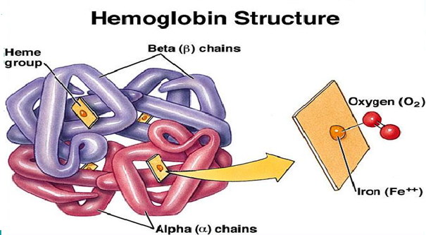
polypeptide chains are the same in fetal hemoglobin, normal adult hemoglobin, and sickle cell hemoglobin. For simplicity, this activity ignores the quaternary structure of hemoglobin.

Figure B on page 1 of the Student Handout summarizes the effects of homozygous sickle cell alleles, which result in sickle cell anemia. Even in a person who has severe sickle cell anemia, most red blood cells are not sickled most of the time. The degree of clumping of sickle cell hemoglobin into rods varies, depending on factors such as differences in dehydration and oxygen levels in the blood. For example, dehydration increases the concentration of hemoglobin in red blood cells which increases the tendency of sickle cell hemoglobin to clump into rods. The resulting sickled red blood cells can block some of the small blood vessels, which can cause pain and organ damage (called a sickling crisis). An infection that induces vomiting and diarrhea can result in dehydration which can cause a sickling crisis. However, the causes of most sickling crises are unknown. A good summary of the medical aspects of sickle cell anemia, including symptoms, diagnosis and treatment, is available at https://www.mayoclinic.org/diseases-conditions/sickle-cell-anemia/symptoms-causes/syc-20355876.

How DNA Gives the Instructions for Making a Protein
If your students would benefit from a brief review of transcription and translation, you may want to show them the 5-minute video, “What Is DNA and How Does It Work?” (https://www.statedclearly.com/videos/what-is-dna/).

This section reviews transcription and translation to help students understand how the CRISPR-Cas treatment works (e.g., see flowcharts in questions 10-11). Question 3, with the accompanying figure and explanation, will help students understand how guide RNA binds to the target gene (see question 7 with the accompanying figure).

What is CRISPR-Cas?

You may want to show your students the first 1 minute and 20 seconds of a video that explains how viruses infect and kill bacteria (https://www.britannica.com/video/72951/cycle-infection-results-host-cell-death-release).

Bacteria have evolved a variety of innate and adaptive mechanisms to defend themselves against viral infections (https://innovativegenomics.org/crisprpedia/crispr-in-nature/). CRISPR-Cas is the name for multiple similar adaptive immune defenses against viral infections. CRISPR-Cas9 is one version of CRISPR-Cas.

Page 3 of the Student Handout recommends the ~5-minute video, “What is CRISPR-Cas?” (https://www.youtube.com/watch?v=52jOEPzhpzc). The first 2 minutes and 45 seconds of this video provide a good basic introduction to CRISPR-Cas. You may want to show the first 2 minutes and 45 seconds twice – first as a general introduction and then again after your students have read question 6 so they can look for the answers to questions 6a and 6b.

CRISPR stands for Clustered Regularly Interspersed Short Palindromic Repeats in the bacterial DNA. Sequences of the DNA from viruses that have previously infected the bacterium or its ancestors are inserted between CRISPR sequences in the bacterial chromosome. The CRISPR array is transcribed and processed to give small RNAs that assemble with the Cas proteins; the RNA guides the Cas enzymes to cut the DNA of a virus that re-infects the bacterium. If you want to know more about the molecular biology of CRISPR-Cas, I recommend the excellent introduction, “CRISPR in Nature” (https://innovativegenomics.org/crisprpedia/crispr-in-nature/). You may also want to view the 10-minute video, “But what is CRISPR-Cas9? An animated introduction to Gene Editing” (https://www.youtube.com/watch?v=ANehpGhbuF4).

The top of page 4 of the Student Handout recommends the 1.5-minute video, “CRISPR Explained” (https://www.youtube.com/watch?v=UKbrwPL3wXE). This video provides a concise, clear explanation of the use of CRISPR-Cas9 to edit genes to treat medical problems.

Why did doctors want to increase fetal hemoglobin in Victoria Gray’s red blood cells?
Fetal hemoglobin has a stronger affinity for oxygen than adult hemoglobin, so the fetal blood can absorb oxygen from the mother’s blood. The box on page 4 of the Student Handout summarizes three of the research findings that explain why researchers believed that they could treat severe sickle cell anemia by increasing fetal hemoglobin levels.
- Newborns’ red blood cells have high levels of fetal hemoglobin. Very few red blood cells are sickled in newborns who later develop sickle cell anemia. These observations suggest that fetal hemoglobin inhibits clumping of sickle cell hemoglobin into rods, which prevents the sickling of red blood cells. (This is similar to the anti-clumping effect of normal hemoglobin in individuals who are heterozygous for the sickle cell allele.)
- The severity of sickle cell anemia in different individuals varies from relatively mild sickle cell anemia with few sickling crises and nearly normal health and survival to severe sickle cell anemia with frequent sickling crises, significant organ damage, and early death. Differences in the frequency of sickling crises are correlated with genetic differences that cause some people with sickle cell anemia to naturally produce relatively high levels of fetal hemoglobin.
- Hydroxyurea, which increases the production of fetal hemoglobin, is one treatment for sickle cell anemia. The description of study C includes the information that “hydroxyurea can cause toxicity and helps only about half of all patients”. This observation is irrelevant for the argument that links increased fetal hemoglobin with reduced severity of sickle cell anemia, but it is relevant for understanding the plight of patients with sickle cell anemia. Also, it is important for students to develop the skill of identifying which information is relevant to an argument and which is not.

Additional research evidence that contributed to the development of the CRISPR-Cas gene-editing therapy includes:
- genome-wide association studies for humans that identified the importance of the BCL11A gene for regulating fetal hemoglobin production and
- experiments in mice that showed that inactivating the BCL11A gene could correct sickle cell disease (https://answers.childrenshospital.org/sickle-cell-gene-therapy-bcl11a-timeline/).
The multiple types of types of research that contributed to understanding the role of fetal hemoglobin and the BCL11A gene illustrate an NGSS generalization about the nature of science, “Scientific investigations use a variety of methods, tools, and techniques to revise and produce new knowledge.”

How Doctors Have Used CRISPR-Cas to Increase Production of Fetal Hemoglobin
Question 9 asks students whether the gene for fetal hemoglobin is present in the cells of a one-year-old, even though these cells no longer make fetal hemoglobin. Students should understand that:
- new cells are produced by mitosis, which ensures that each new cell has all the genes present in the original zygote;
- a gene is still present, even when transcription of the gene is turned off.
The subsequent paragraphs and figures in the Student Handout and these Teacher Notes explain how transcription of the fetal hemoglobin gene is turned off. This is an example of a much more general phenomenon – the regulation of gene expression at different stages of development and in different types of cells.

A transcription factor is a protein that controls the rate of transcription of one or more genes. Page 5 of the Student Handout introduces the BCL11A transcription factor, which is the proximal cause of the transition from producing fetal hemoglobin to producing adult hemoglobin around the time of birth. The figure below shows how the BCL11A protein binds to the DNA at the beginning of the fetal hemoglobin gene and inhibits transcription of the fetal hemoglobin gene and increases transcription of the “adult” hemoglobin gene.

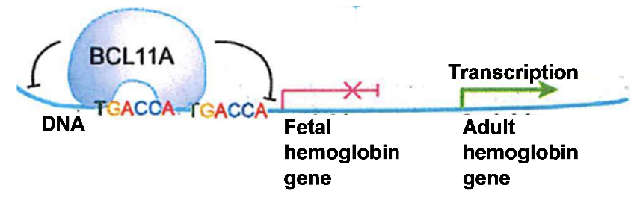 | Adapted from Liu et al., 2018, Cell 173:430-442

The figure below illustrates that, as levels of the BCL11A protein increase around the time of birth, there is a gradual transition from making the gamma polypeptide in fetal hemoglobin to making the beta polypeptide in “adult” hemoglobin. Notice that symptoms of sickle cell disease begin about three months after birth.

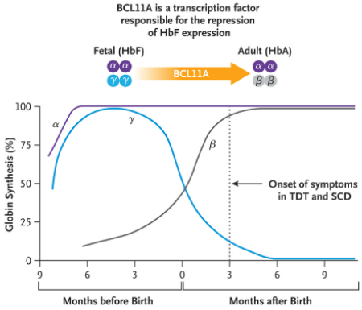 | Globin = heme-containing globular proteins; TDT = transfusion dependent thalassemia; SCD = sickle cell disease.  Figure from “CRISPR-Cas9 Gene Editing for Sickle Cell Disease and β- Thalassemia” (New England Journal of Medicine, 2021; 384:252-60)

Victoria Gray’s CRISPR-Cas treatment made double-stranded cuts in the BCL11A gene. Cells have several mechanisms for repairing double-stranded cuts of the DNA. However, these repair mechanisms make mistakes, so a nonfunctional protein is produced (https://www.synthego.com/blog/crispr-dna-repair-pathways#:~:text=CRISPR%20Induces%20DNA%20Repair%20Pathways,off%20whenever%20a%20break%20occurs.). The effects of the normal BCL11A gene are summarized in flowchart A on page 5 of the Student Handout, and the effects of damaging the BCL11A gene are summarized in flowchart B on the same page.

Page 5 of the Student Handout recommends the first 10 minutes of the video, “How Gene Editing Is Curing Disease” (https://www.youtube.com/watch?v=ezfwqmKC9Uc). The first minute reviews basic information about sickle cell anemia. Then, the narrator mentions that some people with sickle cell anemia are treated with bone marrow transplants. Unfortunately, no suitable bone marrow donor can be found for a majority of patients with severe sickle cell anemia.

To understand why bone marrow transplants can cure sickle cell anemia, you need to know that the development of red blood cells begins with stem cells in the bone marrow. When a stem cell divides, one of the daughter cells becomes a replacement stem cell and the other daughter cell becomes a more differentiated cell. In the final stage of the development of red blood cells, the nucleus and mitochondria are ejected and protein production stops. For additional information about red blood cell production, see https://medlineplus.gov/ency/anatomyvideos/000104.htm and https://www.youtube.com/watch?v=cATQFej6oAc.

Beginning at minute 2 and ending at minute 7, the recommended video, “How Gene Editing Is Curing Disease”, explains the function of CRISPR-Cas and its application for treating sickle cell anemia. The diagrams in this portion of the video include a label for PAM, which is the “protospacer adjacent motif”, which helps to precisely target the cut in the DNA (https://innovativegenomics.org/crisprpedia/crispr-in-nature/).

This figure shows the main steps for the gene therapy that Victoria Gray received. Stem cells were removed from her bone marrow and edited with CRISPR-Cas. Before her edited stem cells were returned to her blood, she was treated with a drug that killed the stem cells in her bone marrow to make room for the edited stem cells to repopulate the bone marrow. This drug treatment is responsible for most of the serious side effects mentioned in the recommended video. These serious side effects are one reason why gene editing is only considered for patients with severe sickle cell anemia (question 12). | 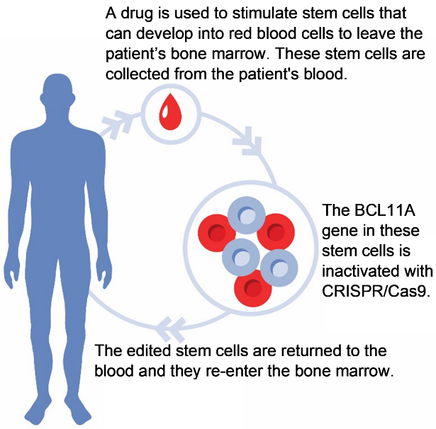

Data supporting the effectiveness and safety of this CRISPR-Cas9 gene editing treatment for severe sickle cell disease were the basis for the 2023 FDA approval of this treatment (https://www.genengnews.com/topics/genome-editing/fda-approves-the-first-crispr-therapy-for-sickle-cell-disease/). Two advantages of CRISPR-Cas9 gene editing that inactivates the expression of the BCL11A gene are:
- Inactivation of the BCL11A gene not only activates the production of the gamma polypeptide in fetal hemoglobin, but also down-regulates the production of the mutant beta polypeptide in sickle cell hemoglobin.
- Using CRISPR-Cas to inactivate a gene is easier than correcting the sickle cell mutation, which requires homology-directed repair (see figure below).

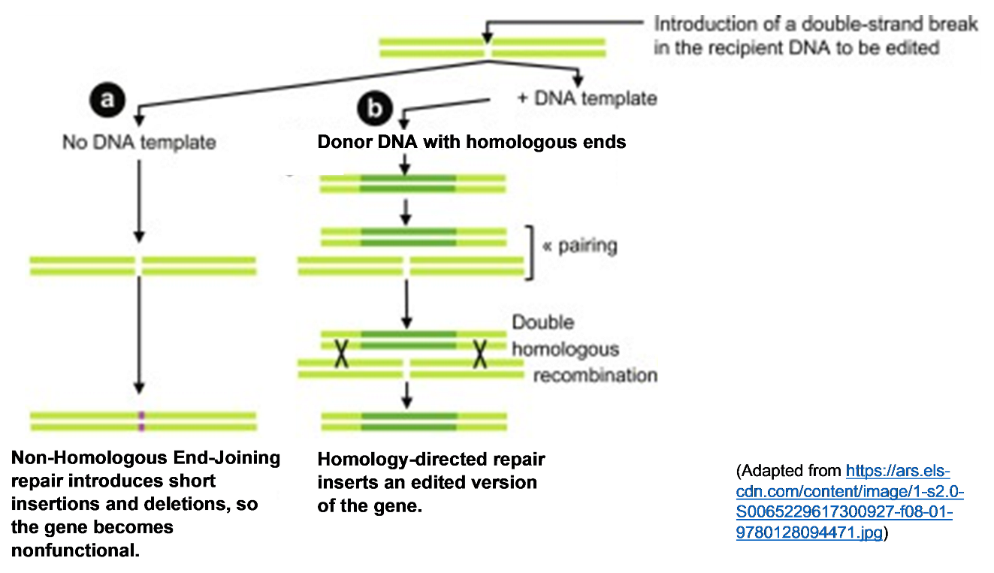

Researchers are developing other types of gene therapy for sickle cell anemia. For example, gene therapy that uses a virus to carry in a modified gene for the beta polypeptide in hemoglobin is described in the informative 7-minute video, “UCLA gene therapy trial for sickle-cell disease: Evie’s story” (https://www.youtube.com/watch?v=XmQJpuLx07Y). Unfortunately, two patients who received a gene therapy that used a virus to carry in an edited hemoglobin gene have developed cancer or precancer (https://www.sciencemag.org/news/2021/02/gene-therapy-trials-sickle-cell-disease-halted-after-two-patients-develop-cancer). This may be due to the virus inserting the edited gene in the wrong place. One advantage of CRISPR-Cas9 is that it appears to result in little off-target editing. Nevertheless, the viral therapy was also approved by the FDA in 2023. Additional drugs for treating sickle cell anemia have been approved by the FDA or are in various stages of clinical testing (https://www.nature.com/articles/d41586-021-02141-1).

If any of your students are interested in clinical trials of gene therapy for sickle cell disease, they can find information at https://www.clinicaltrials.gov/ct2/results?cond=Sickle+Cell+Disease&term=Gene+therapy&type=Intr&rslt=&age_v=&gndr=&intr=&titles=&outc=&spons=&lead=&id=&cntry=&state=&city=&dist=&locn=&rsub=&strd_s=&strd_e=&prcd_s=&prcd_e=&sfpd_s=&sfpd_e=&rfpd_s=&rfpd_e=&lupd_s=&lupd_e=&sort=. Additional gene editing therapies for a variety of diseases are in various stages of development and clinical testing (https://www.nature.com/articles/d41586-023-03797-7#:~:text=Landmark%20approval%20of%20the%20first,and%20more%20precise%20genome%20editors.; https://www.synthego.com/blog/crispr-2023-breakthroughs). Some students may be interested in “Is gene therapy available to treat my disorder?” (https://medlineplus.gov/genetics/understanding/therapy/availability/).

Optional Discussion of Ethical Issues
If you want your students to discuss the ethical concerns related to the potential uses of CRISPR-Cas, you could add the following at the end of the Student Handout.

To learn about other possible uses of CRISPR-Cas and related ethical controversies, view “Gene Editing and CRISPR – How far should we go?” (https://learn.kqed.org/discussions/25).

13. How do you think gene editing should be regulated? What safeguards and limitations would you recommend? Explain your reasoning.

The recommended optional 6-minute video, “Gene editing and CRISPR: How Far Should We Go?” (https://learn.kqed.org/discussions/25), introduces some of the potential uses of CRISPR and the related ethical controversies. The presentation is generally accurate, but it exaggerates the potential benefits of gene editing because it underestimates the complexities of polygenic inheritance and environmental influences on human characteristics.

Issues for students to consider as they answer optional question 13 include:
- how to prevent harmful side effects as a result of gene editing,
- possible long-term effects of gene editing reproductive cells, and whether to extend this type of gene editing past prevention of clear-cut diseases.

The multiple complex issues to be considered are indicated by the proposal that heritable germline editing should only be done if all of the following criteria are met:
- absence of reasonable alternatives
- restriction to preventing a serious disease or condition
- restriction to editing genes that have been convincingly demonstrated to cause or to strongly predispose to the disease or condition
- restriction to converting such genes to versions that are prevalent in the population and are known to be associated with ordinary health with little or no evidence of adverse effects
- availability of credible pre-clinical and/or clinical data on risks and potential health benefits of the procedures
- ongoing, rigorous oversight during clinical trials of the effects of the procedures on the health and safety of the research participants
- comprehensive plans for long-term multigenerational follow-up while still respecting personal autonomy
- maximum transparency consistent with patient privacy
- continued reassessment of both health and societal benefits and risks, with broad ongoing participation and input by the public
- reliable oversight mechanisms to prevent extension to uses other than preventing a serious disease or condition (https://www.nap.edu/resource/24623/Criteria_for_heritable_germline_editing.pdf).

These proposed principles are related to the NGSS nature of science principle, “Science and technology may raise ethical issues for which science, by itself, does not provide answers and solutions.”

Some additional helpful resources are:
- “A gene editing game changer?” (https://www.youtube.com/watch?v=TnMCK73Q9V0; an 8-minute video that includes interviews with Victoria Gray and her doctor and introduces some of the ethical concerns with germline editing).
- “Is germline gene therapy ethical?” (https://www.yourgenome.org/debates/is-germline-gene-therapy-ethical)
- Use Gene Editing to Treat Patients, Not Design Babies (https://www.youtube.com/watch?v=tKOfbgIJxuI)
- Human Genome Editing: Science, Ethics, and Governance (https://www.nap.edu/catalog/24623/human-genome-editing-science-ethics-and-governance)

Related Learning Activities
- “Building a Paper Model of CRISPR-Cas9” (https://www.biointeractive.org/classroom-resources/building-paper-model-crispr-cas9)
- “CRISPR in a Box Educational Kits” (https://www.rockland.com/crispr-in-a-box/)
- “Genetic Engineering Challenge – How can scientists develop a type of rice that could prevent vitamin A deficiency? (https://serendipstudio.org/exchange/bioactivities/geneticengineer)

Sources for Figures in Student Handout
- Victoria Gray, https://i.dailymail.co.uk/1s/2020/06/23/21/29972628-8452641-image-a-7_1592944751764.jpg
- Figure showing effects of normal and sickle cell alleles, adapted from https://www.medicalhomeportal.org/image/345 and https://mysciencesquad.weebly.com/uploads/1/1/8/3/118361154/published/sickle-cell-consequence-med.jpeg?1533829624
- Figure at the top of page 2, adapted from https://www.labiotech.eu/wp-content/uploads/2015/12/transcription_translation_mRNA_DNA-300x287.jpg
- Figure in the middle of page 2, adapted from Krogh, Biology – A Guide to the Natural World.
- Figure at the bottom of page 2, adapted from https://images.saymedia-content.com/.image/t_share/MTc0MTY5ODg1MDM0MDk2MTI0/protein-production-a-step-by-step-illustrated-guide.jpg
- Figure of virus infecting bacterium on page 3, adapted from https://www.researchgate.net/profile/Aidan-Coffey/publication/304571332/figure/fig1/AS:613935124340738@1523384948021/Bacteriophage-replication-cycle-virulent-phage.png
- Figure of CRISPR/Cas 9 on page 4, https://noonansyndrome.com.au/wp-content/uploads/2017/02/crispr-cas9-at-work-data.jpg
- Flowcharts on page 5 created by the author

Victoria Gray quotations are from https://www.mainepublic.org/2019-10-10/after-a-life-of-painful-sickle-cell-disease-a-patient-hopes-gene-editing-can-help and https://www.npr.org/sections/health-shots/2020/06/23/877543610/a-year-in-1st-patient-to-get-gene-editing-for-sickle-cell-disease-is-thriving.

By Dr. Ingrid Waldron, Department of Biology, University of Pennsylvania, © 2024. These Teacher Notes and the related Student Handout are available at https://serendipstudio.org/exchange/bioactivities/GeneEdit.
If you have not used either of these activities to help your students understand transcription and translation, you may want to introduce the genetics and pathophysiology of sickle cell anemia with the analysis and discussion activity, "The Genetics of Sickle Cell Anemia and Sickle Cell Trait – How One Gene Affects Multiple Characteristics" (https://serendipstudio.org/exchange/bioactivities/geneticsSCA).
Next Generation Science Standards (http://www.nextgenscience.org/next-generation-science-standards)
To draw a shape, at the top of the page, find and click Shape, choose the shape you want to use, and then click and drag on the canvas to draw your shape. To insert text, click Insert at the top of the drawing. Click Text Box and drag it to where you want it. Type your text. When you are done, click Save and Close.
Source of figure = https://1.bp.blogspot.com/-jzbeLThWT6s/Xji0ExYTfCI/AAAAAAAAGyI/XxNjKs0BGH8DS_VuEI_w9uZb_LKlDKx3wCLcBGAsYHQ/s640/Hemoglobin.png
In this figure, the top DNA strand is the template strand, which is used to make mRNA. An individual who is heterozygous for the sickle cell allele (i.e., has sickle cell trait) rarely has symptoms of sickle cell anemia because each red blood cell contains both normal and sickle cell hemoglobin and the normal hemoglobin generally prevents clumping of the sickle cell hemoglobin. This is similar to the effect of fetal hemoglobin, which also inhibits clumping of sickle cell hemoglobin. More information about sickle cell anemia and sickle cell trait is provided in the analysis and discussion activity available at https://serendipstudio.org/exchange/bioactivities/geneticsSCA.
Next Generation Science Standards (http://www.nextgenscience.org/next-generation-science-standards)
This treatment is also used before a bone marrow transplant. The figure is from https://mk0labiotecheugl43g7.kinstacdn.com/wp-content/uploads/2017/12/CRISPR-cas9-ex-vivo.jpg.
Next Generation Science Standards (http://www.nextgenscience.org/next-generation-science-standards)

